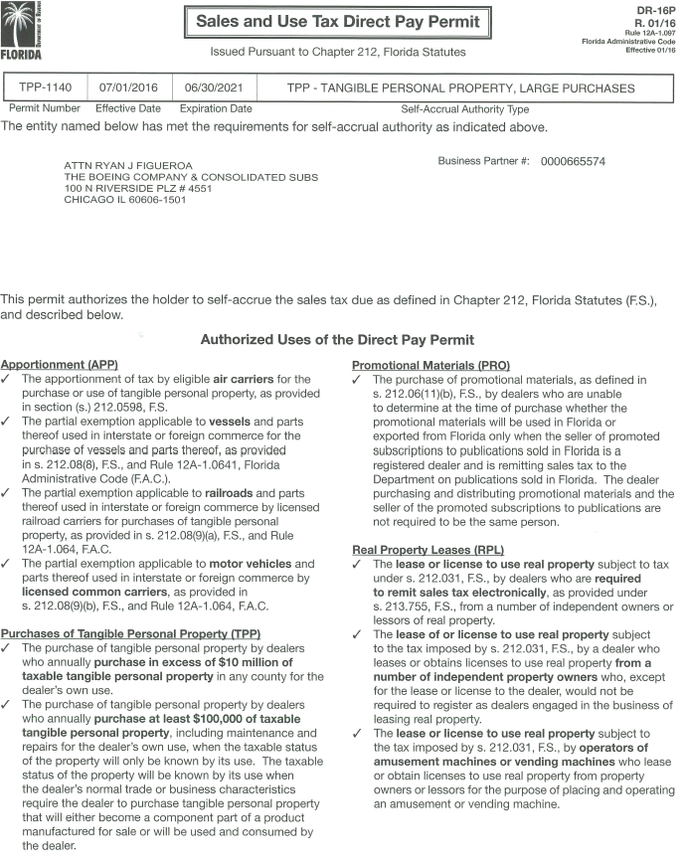

IF YOU HAVE ANY QUESTIONS, PLEASE SEE THE FREQUENTLY ASKED QUESTIONS ON THE BACK
tHE boeing company FLORIDA direct pay PERMIT
FREQUENTLY ASKED QUESTIONS

- What is a direct pay permit? This is an agreement between The Boeing Company, (“TBC”), and a taxing jurisdiction, whereby the sales and use tax due to the taxing jurisdiction will NOT be paid to the vendor. Instead, TBC will determine the taxable amount and remit it to the taxing jurisdiction directly.

- What should I do with this permit? This permit should be retained in your tax records to support your billings to TBC when your company is audited by the State of Florida. Upon audit, provide this permit to the auditors, and the auditors should not review your TBC transactions. (These transactions will be reviewed when the taxing jurisdiction audits TBC.)

- Your customer name in my records states Boeing Space Operations Company, is this still a subsidiary of TBC? NO, effective January 1, 2017, Boeing Space Operations Company, a wholly-owned subsidiary of TBC was dissolved into TBC.

- How do I know what Boeing legal entity is purchasing from my company? If you do not know the legal entity that is purchasing products from your company, please refer to the purchase order terms and conditions; the legal entity and its state tax ID number will be listed in the tax clause.

- The ship-to address on your purchase order is different than the address on your permit which lists 100 N Riverside Plaza, Chicago Illinois as the TBC address, can I still accept this permit? YES, the address listed on the permit is The Boeing Company’s corporate address. All TBC tax documents list this address.

- Do I need a new permit for every purchase? NO, the attached direct pay permit is good for all TBC purchases shipped into the State of Florida; this permit will only expire upon revocation by the State.

- My company ships to multiple states can I use this permit for all the shipments? NO, this permit is only good for shipments into the State of Florida. When you ship to another state, you will need to charge tax, unless you have received other supporting documents. If our purchase is annotated as “resale” the tax clause found in our terms and conditions should contain the necessary information to claim this exemption in many states.

- I receive orders from other Boeing legal entities; can I use this permit for those orders? NO, this permit is only good for purchases made by TBC.

- I no longer do business with TBC, should I keep this permit? YES, for two reasons; first, to support your previous tax free shipments to TBC. And second, if you plan to do business with TBC in the future, you will already have this permit in your file.

- Do you have other TBC Direct Pay Permits? YES, other permits for the states of Alabama, Arizona, Missouri, South Carolina, Texas, and Washington are available upon request, please contact Dennis G. Moeller at dennis.g.moeller@boeing.com.

If you have any other questions, please contact Dennis G. Moeller at dennis.g.moeller@boeing.com.

